Monday  Oct. 18 | 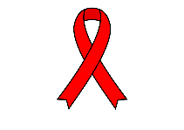  “Red-y” to be Drug Free  Wear red
Tuesday  Oct. 19 | Team Up Against Drugs  Wear sports team gear
Wednesday  Oct. 20 | No Drugs in My Future  Wear EAHS or college/university gear
Thursday  Oct. 21 | Scare Away Drugs  Wear black and orange
Friday  Oct. 22 | Dream of a Drug Free Future  Wear pajamas

